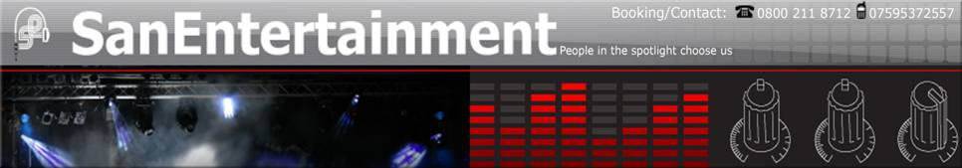

NOTE:
Please After adding your details to this document could you kindly send it along with your Picture to SAN Entertainment to info@sanentertainment.co.uk and I will add the Document and Picture to the Website.

Entertainer Biography

The UK's hottest high class party band for all special occasions.

Boogie Express offer the very best in quality entertainment and are the perfect choice for your wedding, party, function, corporate event or indeed any event that calls for a great party band . This isn't just any live band - they offer a complete one stop entertainment service. You can book extras such as a DJ, Jazz Band, Jazz Pianist or Jazz Guitarist.

The act have a massive repertoire of the most popular material from over five decades. Boogie Express guarantees to get any audience on their feet and ‘In the Mood’! All the best eras and styles are covered including Funk, Disco, Soul, 50s, 60s, 70s, 80s, 90s, 00s and beyond.

Boogie Express features some of the best musicians in the country! The show incorporates live drums, saxophone, bass guitar, guitar, keyboards and percussion topped with superb lead vocals and harmonies.

Supplementing the stunning live performance is an ultra high fidelity sound system and fully choreographed light show. When all these elements are combined the result is truly stunning!

REMEMBER - Boogie Express also offer extras such as a Jazz Trio (adds a real touch of class during meals or at a Champagne Breakfast) and a DJ service!

Whatever your needs, this live outfit offers the complete entertainment solution. As professionals Boogie Express will take care of it all leaving you to enjoy your event - something not all party bands can offer!

Boogie Express thank you for stopping by and look forward to working with you in the near future...

" Sarah-Jane and myself were both really impressed with your band at our wedding on 16th September. The choice of music appealed accross the generations with 8 & 10 year olds dancing at the same time as their 81 year old great grandmother. Indeed several people were seen on that dance floor who no one could ever remember dancing before.
Thanks for making our wedding reception exactly what we wanted it to be - a great party!"

Entertainers Pictures

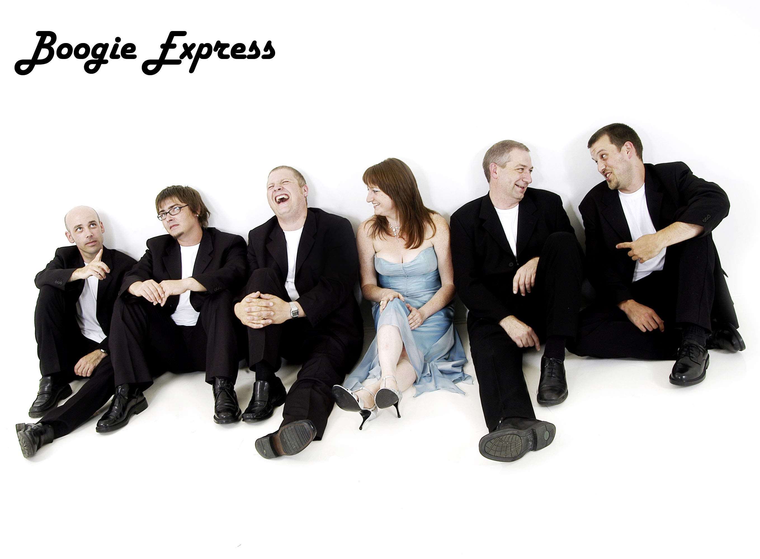
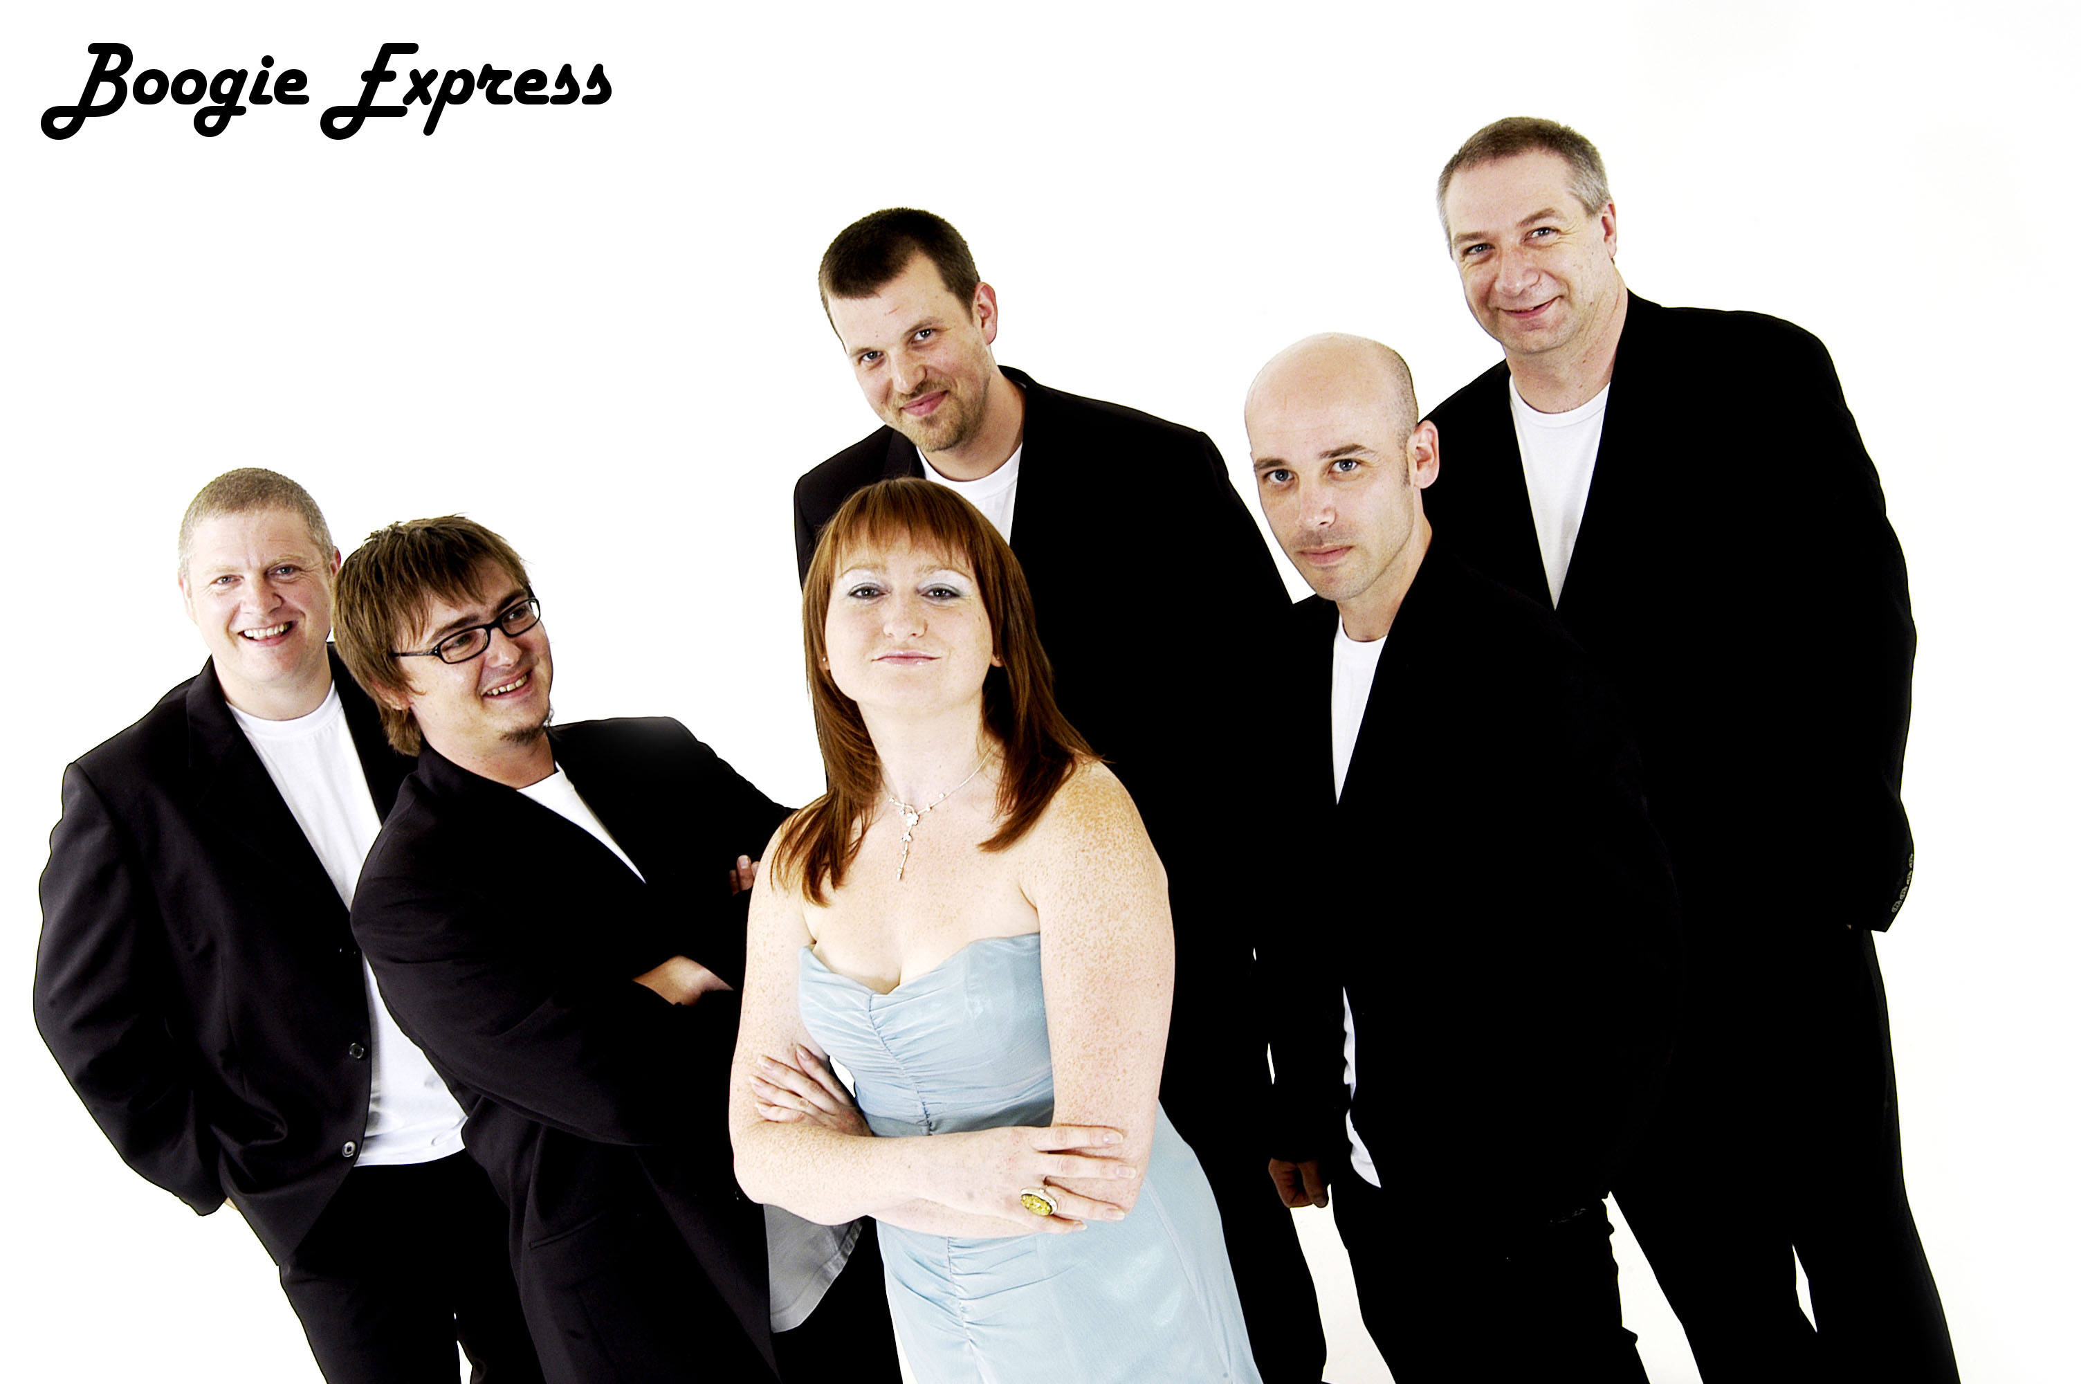

Sample Playlist

- Blame it on the Boogie
- Life is a Roller Coaster
- I’m Outta Love
- Walking on Sunshine
- 60’s medley (It takes 2; Locomotion; Will you Love me Tommorrow etc.)
- I Feel Like a Woman
- Uptown Girl
- One Way or Another
- Abba medley
- Disco Inferno
- Soul medley (Sweet Soul Music, Midnight Hour, Rescue Me, Respect etc.)
- Living La Vida Loca
- Don’t Stop
- The Only Way is Up
- Car Wash
- Dance the Night Away
- Mony Mony

