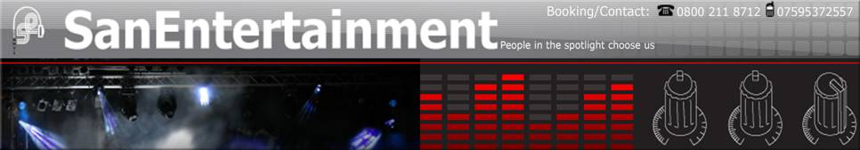

Entertainer Biography & Equipment Type

Scottish Wedding Band - Function Band Scotland

"DeZine" are a "high-tech", 3-piece live band, featuring superb male and female vocals and tight, powerful harmonies. We utilise the very latest in sound reinforcement (line-array) and lighting equipment to provide an astonishing aural and visual experience. Most of all, we are a "party" band - without the "cheesiness"! We like to ensure that your guests/clients leave your engagement buzzing with excitement and singing their way out the door on the road home! However, a classy and sophisticated performance can be supplied if required. With a quite unrivalled song repertoire that is constantly evolving (we don't like our set to gather dust!) and features Ceilidh tunes, contemporary and classic rock, rock'n'roll and pop songs (and some classic "swing" numbers) you can be assured of an experience and level of service that is unprecedented. Book DeZine. Have fun

We try to keep our song lists as up to date as we can, however as we are constantly adding new material to our repertoire, it isn't always possible to include every song we cover.

So just because it isn't here, doesn't mean we don't do it, please just ask!

If you are choosing a song as your first dance on your wedding day DeZine Wedding Band insist that you pick the song that is most personal to you. It is our job as professional entertainers to learn and perform it to the highest standard. If your song isn't on any of our lists don't worry chances are we know it anyway, but if not we only require 2 weeks notice to have it perfect for your wedding day.

SONG LIST

Ceilidh

CANADIAN BARN DANCE
CIRCASSIAN CIRCLE
DASHING WHITE SARGEANT
GAY GORDONS
MILITARY TWO STEP
PRIDE OF ERIN WALTZ
ST BERNARDS WALTZ
STRIP THE WILLOW
Modern Rock,
Pop and Dance
ALL THE SMALL THINGS
ALL THE TIMES
AMAZED
AMERICA
BEAUTIFUL
BIG GIRLS
BLACK AND GOLD
BLACK HORSE & THE CHERRY TREE
BLEEDING LOVE
CALL THE SHOTS
CASTLES IN THE SKY
CHASING CARS
CRAZY
DAKOTA
DO YOU WANT TO
DON'T STOP THE MUSIC
EVERYBODY'S CHANGING
FILTHY GORGEOUS
FROM PARIS TO BERLIN
GET THE PARTY STARTED
GRACE KELLY
HALLELUJAH - ALEXANDRA BURKE VERSION
HERE IN YOUR ARMS
HERO - DANCE VERSION
HERO - SLOW VERSION
HOT N COLD
HOME
HUNG UP
HUMAN
I BELIEVE IN A THING CALLED LOVE
I CAN'T DECIDE
I DON'T FEEL LIKE DANCING
IN YOUR ARMS
IS IT COS I'M COOL
TAKE YOUR MAMA
KISS YOU OFF
LAURA
LEAVE ME ALONE
LIFE WITH YOU
MANEATER
MARIA
MERCY
MONSTER
MR BRIGHTSIDE
MR ROCK N ROLL
MUSIC IS THE VICTIM
NOW YOU'RE GONE
PIECE OF ME
RULE THE WORLD
RUN
SAVING MY FACE
SEX ON FIRE
SHE'S MY MAN
SHINE
SO WHAT
SUDDENLY I SEE
SUPERSTAR
THANK YOU
THE BOY DOES NOTHING
THE BOYS OF SUMMER - DANCE VERSION
THE OTHER SIDE
THE TIDE IS HIGH
THIS IS THE LIFE
TIME OF YOUR LIFE
TITS ON THE RADIO
VALERIE
WARM THIS WINTER
WHO KNEW
YOU'RE BEAUTIFUL
COMFORTABLY NUMB
I THINK WE'RE ALONE NOW
I TRY
LYLA
MARY
STANDARD

CHY BREAKY HEART
AMARILLO
BLANKET ON THE GROUND
DON'T GO BREAKING MY HEART
ENDLESS LOVE
EVERYTHING I DO I DO IT FOR YOU
FOOTLOOSE
HAVE I TOLD YOU LATELY
HEAVEN - BRYAN ADAMS VERSION
I DON'T WANT TO MISS A THING
IF TOMORROW NEVER COMES
IF YOU DON'T KNOW ME BY NOW
IT HAD TO BE YOU
CANDLE IN THE WIND
COME FLY WITH ME
COULD I HAVE THIS DANCE

Classic Rock
and Pop
500 MILES
A LITTLE RESPECT
ALL NIGHT LONG
ALRIGHT NOW
ALWAYS THE LAST TO KNOW
BABY CAN I HOLD YOU
BABY JANE
BACK ON THE CHAIN GANG
BRASS IN POCKET
BROWN EYED GIRL
BUILD ME UP BUTTERCUP
CALEDONIA
CAN'T GET ENOUGH
COWARD OF THE COUNTY
CRACKLIN' ROSE
CRAZY LITTLE THING
DANCE THE NIGHT AWAY
DANCING IN THE DARK
DANCING ON THE CEILING
DANCING WITH TEARS IN MY EYES
DEAD RINGER FOR LOVE
DECEMBER OF 63
DIGNITY
DISCO INFERNO
DON'T YOU FORGET ABOUT ME
I BELIEVE IN A THING CALLED LOVE
I CAN'T DECIDE
I DON'T FEEL LIKE DANCING
DOWN UNDER
DROP THE PILOT

