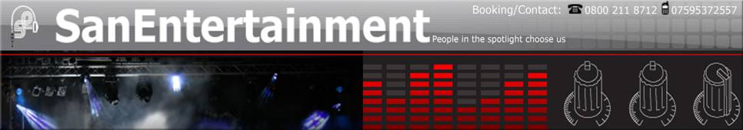

Entertainer Biography & Equipment Type

You had also asked for information on my repertoire, which will be listed below. I don't really have a songlist as I've over 500 songs from which to choose... quite a lot.
I pride myself on versatility, as you will see when you read the list..

REPERTOIRE

Tom Jones set of 20 tracks

Rat Pack or Sinatra set of +/- 35 tracks includes favourites of Dean Martin and Sammy Davis jr.
some Sinatra live versions

Elvis Presley selection of over 150 tracks. including many live versions and originals

Queen set of +/- 20 tracks

Robbie Williams set of +/- 20 tracks

Soul set of various artists, motown to 80's
includes eddie floyd, wilson pickett, blues brothers, stevie wonder, lionel richie, etc.

Rock n roll set, Jerry lee lewis, chuck berry, elvis,etc

classic rock set, includes ZZtop, U2, Aerosmith, Creedence Clearwater Revival, Rod Stewart,Eagles and more

80's set, includes Wham, Eddie grant, phil collins, Don henley, elton john, paul simon, prince, ub40

party sets of more than a 100 tracks to choose from, a lot more when incorporated with tracks from other sets

golden oldies set, derived from the prementioned sets and more that are available from the list..

All these sets are interchangeable to form differently themed nights.

Also, I have a fairly extensive collection of music to entertain with in between sets, if more than one is required on an evening.
As I have before mentioned I prefer gigs in and around Glasgow, due to transportation issues, but I am planning to expand in the future..
However, if there is a gig somewhere outside Glasgow available for an acceptable fee,(one that covers transportation costs) than please do notify me.

I hope all the information I have included will be sufficient, if not please contact me through the e-mail adress used.

With very kind regards,

John Barry

Entertainers Pictures

Sample Playlist Please send us a sample track of less than 2mb in size

- Jailhouse Rock - Elvis Presley (Example)

