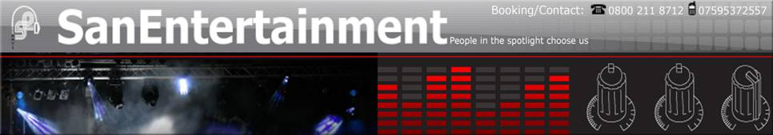

Entertainer Biography & Equipment Type
InDefinately is an established 5-piece function band consisting of male & female lead vocals, lead and rhythm guitars, bass guitar, drums, keyboards and multi-part backing vocals.
We primarily play Pop & Rock classics from the fifties right through to the latest chart hits, but also dabble in Blues, Funk, Soul, Disco and Jazz.
Equally at home playing in the local pub, at private weddings and parties or at large corporate events, our professionalism and musicianship is complimented by a keen sense of humour, audience interaction and an outright determination to entertain.
Based in Buckinghamshire, we regularly play in London and all over the UK.

Songs
!nDefinately can tailor their set to meet the requirements of your occasion. We primarily play Pop & Rock classics from the fifties to the nineties and right through to the latest chart hits, but also dabble in Blues, Funk, Soul, Disco and Jazz. We welcome requests, both at our public gigs and (with sufficient notice) at private parties and events.
Our current live set continues to grow on a weekly basis, and currently includes, but is not limited to, the following:

20th Century Boy T-Rex  500 Miles The Proclaimers  All Right Now Free  Angels Robbie Williams  Another One Bites The Dust Queen  Are You Gonna Go My Way? Lenny Kravitz  At the Hop Danny & The Juniors  Back In Black AC/DC  Basket Case Green Day  Beat It Michael Jackson  Billie Jean Michael Jackson  Blue Suede Shoes Elvis Presley  Brass In Pocket The Pretenders  Brown Eyed Girl Van Morrisson  Brown Sugar The Rolling Stones  Call Me Blondie  Cannonball Damien Rice  Can't Get Enough Bad Company  Champagne Supernova Oasis  Day Tripper The Beatles  Disco Inferno The Trammps  Easy EThe Commodores  Eight Days A Week The Beatles  Fly Away Lenny Kravitz  Hard to Handle The Black Crowes  Harder To Breathe Maroon 5  Hey Jude The Beatles  Hey Ya Outkast!  Honky Tonk Women The Rolling Stones  Hotel California The Eagles  Hound Dog Elvis Presley  I Feel Fine The Beatles  I Predict A Riot The Kaiser Cheifs  I'm a Believer The Monkees  Jailhouse Rock Elvis Prelsey  Johnny B Goode Chuck Berry  Just A Girl No Doubt  Kids Robbie Williams  Knockin' On Heaven's Door Bob Dylan / Guns N' Roses  La Bamba Richie Valens  Lady Marmalade Patti LaBelle  Layla (Unplugged) Eric Clapton  Let Me Entertain You Robbie Williams |  | Livin' on a Prayer Bon Jovi  Long Train Runnin' The Doobie Brothers  Love Shack The B52's  (In The) Midnight Hour Wilson Pickett  Make Me Smile (Come Up & See Me) Steve Harley  Message In A Bottle The Police  Monkey Wrench The Foo Fighters  Naive The Kooks  No Particular Place To Go Chuck Berry  No Woman, No Cry Bob Marley & The Wailers  Place Your Hands Reef  Play that Funky Music Wild Cherry  Pride (In The Name Of Love) U2  (The) Power of Love Huey Lewis & The News  Rocks Primal Scream  Rock & Roll Led Zeppelin  Sail Away David Gray  Satisfaction The Rolling Stones  Should I Stay Or Should I Go? The Clash  Since U Been Gone Kelly Clarkson  Since You've Been Gone Rainbow  Stand By Me Ben E. King  Stuck in the Middle Steeler's Wheel  Sultans of Swing Dire Straits  Summer of '69 Bryan Adams  Superstition Stevie Wonder  Seven Nation Army The White Stripes  Sweet Child O' Mine Guns N' Roses  Sweet Home Alabama Lynyrd Skynyrd  Take It Easy The Eagles  Take Your Mamma The Scissor Sisters  The Joker Steve Miller Band  The Riverboat Song Ocean Colour Scene  This Love Maroon 5  Tribute Tenacious D  Two Princes The Spin Doctors  Twist & Shout The Beatles  Vertigo U2  Walk This Way Aerosmith  When The Sun Goes Down Arctic Monkeys  Wherever You Will Go The Calling  With Or Without You U2  Wonderwall Oasis

